TEAM COMPETITION

Solution

The position of the observer is given after being determined using GPS: longitude, latitude, and altitude. In fact, only latitude is necessary in the analysis. We have two spatial points (observer position and reference point/peak of main stupa), so we can use the classical formula to calculate the declination of celestial bodies, that is,

$$\sin{δ}= \sin{ϕ} \sin{h}+ \cos{ϕ} \cos{h} \cos{A_{z}}$$

in order to determine the alignment direction.

Thus, students should :

- determine azimuth of the object using a magnetic compass (assuming that it points to the true north);
- determine the elevation angle between their position and the peak of the stupa using protractor and a weighted string;
- determine the declination using the measured parameters;
- identify the constellation using provided star chart based on the results a-c, assuming that the observations are performed at 18:00.

See Table below.

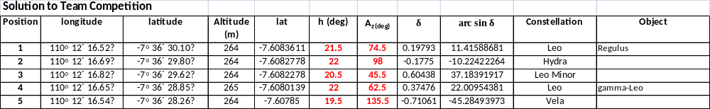
(This is an example only)

Example of panel.

Longitude: 110° 12´ 16.52″ Latitude: -7° 36´ 30.10″ Altitude: 264 m
27

